 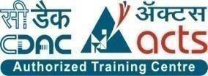

INSTITUTE FOR ADVANCED COMPUTING AND SOFTWARE DEVELOPMENT

AKURDI, PUNE

Documentation On

“Date Quest”

PG-DAC MARCH 2023

# Submitted By

**Group No: 38**

## Roll No. Name:

**233002 Abhijeet Singh**

## 233073 Rajul Gupta

**Ms. Gauri Kadam Mr. Rohit Puranik Project Guide Centre Coordinator**

# ABSTRACT

This project report outlines the development of a user-friendly web platform designed to simplify date planning and booking for couples. The platform offers user registration, activity selection, secure payment processing, and feedback features. By focusing on intuitive design and seamless user experience, the platform aims to address the challenges of modern scheduling. User testing confirms positive feedback regarding ease of use and effective planning. This project highlights the importance of user-centric solutions in enhancing leisure experiences.

# ACKNOWLEDGEMENT

I take this occasion to thank God, almighty, for blessing us with his grace and taking our endeavour to a successful culmination. I extend my sincere and heartfelt thanks to our esteemed guide, **Ms. Gauri Kadam** for providing me with the right guidance and advice at the crucial junctures and for showing me the right way. Furthermore, I extend my sincere thanks to our respected **Centre Co-Ordinator, Mr. Rohit Puranik**, for allowing us to use the facilities available. I would like to thank the other faculty members also, on this occasion. Last, but not the least, I would like to thank my friends and family for the support and encouragement they have given me during the course of our work.

**Abhijeet Singh (233002)**

**Rajul Gupta (233073)**

# Table of Contents

**ABSTRACT 2**

**ACKNOWLEDGEMENT 3**

1. **INTRODUCTION 6**
   1. **PURPOSE 6**
   2. **PROBLEM STATEMENT 6**
   3. **PROJECT SCOPE** **7**
   4. **PROJECT OBJECTIVE 8**
   5. **STUDY OF THE SYSTEM 8**
      1. **MODULES** **8**
2. **OVERALL DESCRIPTION 10**
   1. **EXISTING SYSTEM 10**
   2. **PROPOSED SYSTEM 10**
3. **REQUIREMENT SPECIFICATION 11**
   1. **INTERFACE REQUIREMENT 11**
   2. **FUNCTIONAL REQUIREMENT 11**
   3. **NONFUNCTIONAL REQUIREMENT 12**
4. **SYSTEM DIAGRAMS 14**
   1. **ACTIVITY DIAGRAM 14**
   2. **DATA FLOW DIAGRAM 1****7**
   3. **CLASS DIAGRAM 21**
   4. **USE CASE DIAGRAM** **22**
   5. **ER DIAGRAM** **23**
   6. **SEQUENCE DIAGRAM………………………………………………………………………….24**
5. **TABLE STRUCTURE** **25**
6. **PROJECT PHOTOS** **27**
7. **CONCLUSION** **31**
8. **REFERENCES………………………………………………………………………………………..3****2**

**LIST OF FIGURES**

**FIGURE 1: ADMIN ACTIVITY DIAGRAM 14**

**FIGURE 2: USER ACTIVITY DIAGRAM 15**

**FIGURE 3: VENDOR ACTIVITY DIAGRAM 16**

**FIGURE 4: USER DATAFLOW DIAGRAM 17**

**FIGURE 5: ADMIN DATAFLOW DIAGRAM 18**

**FIGURE 6: USER DATAFLOW DIAGRAM 20**

**FIGURE 7: CLASS DIAGRAM 21**

**FIGURE 8: USE CASE DIAGRAM 22**

**FIGURE 9: ER DIAGRAM 23**

**FIGURE 10: SEQUENCE DIAGRAM 24**

**FIGURE 11: TABLE STRUCTURE 25**

**FIGURE 12: PROJECT PHOTOS 27**

# INTRODUCTION

The "DateQuest" project introduces a comprehensive exploration of an innovative web application crafted to transform the landscape of date planning and booking for couples. In today's fast-paced world, finding quality leisure experiences can be challenging, highlighting the need for efficient and enjoyable solutions. This report delves into the inception, development, and potential impact of the DateQuest application. By seamlessly facilitating the process of curating and booking date plans comprising diverse activities, this application redefines the conventional approach to date planning. The report delves into the platform's user-centric design, activity selection process, secure payment integration, and its potential to elevate the realm of leisure experiences. Through this comprehensive analysis, we unveil how DateQuest stands poised to reshape the way couples plan and embark on memorable outings, enhancing the overall quality of their shared moments.

## PURPOSE

The purpose of the "DateQuest" project is to create a valuable and user-centric web application that streamlines the process of planning and booking dates for couples. This application is designed to enhance couples' experiences by providing them with a seamless platform to curate personalized date plans tailored to their preferences and interests. By harnessing the power of technology, the project aims to simplify the often time-consuming and complex task of organizing meaningful outings. With its intuitive interface, comprehensive activity selection, and secure payment system, the "DateQuest" app aims to bridge the gap between couples seeking memorable experiences, ultimately fostering more enjoyable and hassle-free moments together.

## PROBLEM STATEMENT

The central purpose of the "DateQuest" project revolves around developing an interactive web application tailored to couples seeking memorable date experiences. With a global reach, this platform provides accessible and user-friendly tools to streamline the process of planning and booking dates. Designed as an online hub, the system accommodates couples, vendors, and users, each with personalized access to elevate their engagement. By leveraging this technological solution, the project aims to enhance couples' date planning interactions, creating an optimal environment for seamless date arrangements and enriching the quality of their shared moments.

## PROJECT SCOPE

The project scope for "DateQuest" encompasses the development of a robust and adaptable web application designed to simplify and enhance the process of date planning and booking for couples. The project acknowledges the evolving nature of user requirements and aims to address this challenge by creating a platform that can accommodate changing preferences and needs.

The scope includes the following key components:

1. **Comprehensive Date Planning:** The application will provide couples with an intuitive interface to curate personalized date plans. It will offer a diverse range of activities and options to suit various preferences and budgets.
2. **Vendor Integration:** The platform will facilitate collaboration with activity vendors, allowing them to showcase their offerings, manage availability, and receive bookings from users.
3. **User-Friendly Interface:** The application will prioritize a user-centric design, ensuring easy navigation, activity selection, and booking processes.
4. **Secure Payment Processing:** A secure payment gateway will be integrated to enable seamless and safe transactions between users and vendors.
5. **Feedback and Reviews:** The application will enable users to provide feedback and reviews for activities and vendors, enhancing transparency and aiding other users' decisions.
6. **Continuous Improvement:** The project recognizes the importance of ongoing improvement based on user feedback, market trends, and technological advancements.

By addressing these elements, the "DateQuest" project aims to create a valuable tool for couples, revolutionizing their date planning experiences while maintaining the flexibility to adapt to changing user needs and technological advancements.

## PROJECT OBJECTIVE

The key purpose of the "DateQuest" project is to develop an intuitive and efficient web-based application that transforms the way couples plan and experience memorable dates. The project's central focus is on providing couples with a platform that seamlessly facilitates the creation of personalized date plans, integrating a diverse range of activities and vendors. By utilizing innovative algorithms, the project aims to match couples with activities that align with their preferences, ensuring enjoyable and tailored experiences. The purpose is to offer a secure environment where vendors can showcase their offerings, enabling couples to make informed decisions through transparent reviews and ratings. Through the incorporation of streamlined scheduling tools and secure communication channels, the project endeavours to simplify the process of selecting and booking date plans, ultimately enhancing the quality of couples' shared moments.

## STUDY OF THE SYSTEM

## MODULES:

The "DateQuest" system has been meticulously analyzed to incorporate the following modules, each serving distinct roles:

* + - * Admin
      * Customer
      * Vendor
      1. Admin:

The admin holds a supervisory role in the "DateQuest" system. With exclusive access to the admin dashboard, the admin oversees the entire platform's functionality and ensures smooth operations. The admin's key responsibilities include:

* **User Management:** The admin can add, modify, and remove registered couples and vendors.
* **Event Management:** The admin can control the list of activities and events offered by vendors. This includes adding, editing, and removing activities.
* **Monitoring:** The admin can monitor user activity, ensure compliance with platform guidelines, and resolve any issues that arise.
* **Analytics:** The admin can gather insights into user interactions, booking patterns, and popular activities to inform strategic decisions.
  + - 1. Customer
         * The primary user of the "DateQuest" application, referred to as "User," plays a central role in creating and experiencing memorable date plans.
         * Couples will be able to register and log in using their credentials.
         * They can explore various activities, select date plans, and make secure payments through the platform.
      2. Vendor
         * Vendors constitute an integral part of the "DateQuest" ecosystem. These vendors will provide a variety of activities and services that couples can choose from for their date plans.
         * Vendors will be able to register, create and manage activity listings, specify availability, and respond to booking requests from couples.

# OVERALL DESCRIPTION

The "DateQuest" Project introduces an innovative web application designed to simplify and enhance the process of date planning and booking for couples. In today's fast-paced world, finding quality leisure experiences can be challenging, highlighting the need for efficient and enjoyable solutions. "DateQuest" addresses this need by creating a user-centric platform that seamlessly facilitates the creation and booking of personalized date plans. This application aims to redefine the traditional approach to date planning and elevate the overall quality of shared experiences among couples.

## EXISTING SYSTEM

In the current scenario, planning and organizing dates can be time-consuming and often involves searching for various activities and vendors independently. Couples may struggle to find suitable options that align with their preferences and schedules. This fragmented process can lead to suboptimal date experiences and reduced enjoyment.

## PROPOSED SYSTEM

The proposed "DateQuest" application reimagines the date planning process. By offering a curated selection of activities and a user-friendly interface, couples can easily create personalized date plans tailored to their preferences. The application employs advanced algorithms to match couples with activities that align with their interests and availability, streamlining the selection process. With secure payment integration, transparent feedback, and efficient communication channels, "DateQuest" aims to simplify the journey of planning, booking, and experiencing memorable dates.

The project's purpose is to provide a dynamic platform that fosters meaningful connections between couples and their leisure experiences. Through innovative technology and user-centric design, "DateQuest" seeks to reshape the way couples approach date planning, making it an effortless and enjoyable process that enhances the quality of their shared moments.

# REQUIREMENTS SPECIFICATION

## INTERFACE REQUIREMENTS

Various interfaces for the product could be –

* + 1. Login page
    2. Registration form
    3. There will be a screen displaying information about events organized by Vendor.
    4. **SOFTWARE INTERFACE**
       1. Operating System: Windows 10 which supports networking.
       2. Java development toolkit.
    5. **HARDWARE INTERFACE**

Hardware requirements for insurance on internet will be same for both parties which are as follows:

* Processor - Quad Core
* RAM - 8 GB
* Hard Disk – 1 TB
* NIC – For each party 4.3 Communication Interface

## FUNCTIONAL REQUIREMENTS

This section provides a requirement overview of the system. Various functional modules that can be implemented by the system will be-

* + 1. **Registration:** If Users and admin wants to see the details about upcoming events organized by vendors then he/she must be registered, unregistered user can’t see the upcoming events details.
    2. **Login:** User logins to the system by entering valid user email and password for the seeing the events and dates added by vendor.

**3.3.3 Logout:** After seeing the date plans, the user has to logout.

## NON-FUNCTIONAL REQUIREMENTS

Following non-functional requirements will be there in the insurance to the internet:

1. Secure access to consumer’s confidential data.
2. 24X7 availability.
3. Better component design to get better performance at peak time.
4. Flexible service-based architecture will be highly desirable for future extension.
5. Nonfunctional requirements define system properties and constraints.

Various other nonfunctional requirements are:

* + Security
  + Reliability
  + Maintainability
  + Portability
  + Extensibility
  + Reusability
  + Compatibility
  + Resource Utilization

# SYSTEM DIAGRAM

## ACTIVITY DIAGRAM

## 

**Fig.1: Admin Activity diagram**

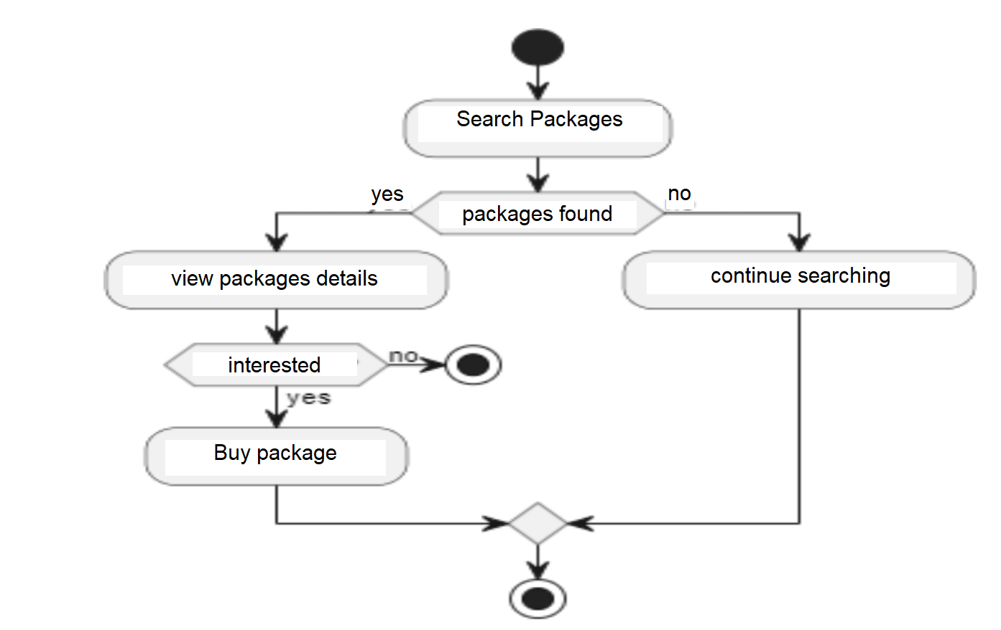

**Fig.2: User Activity diagram**

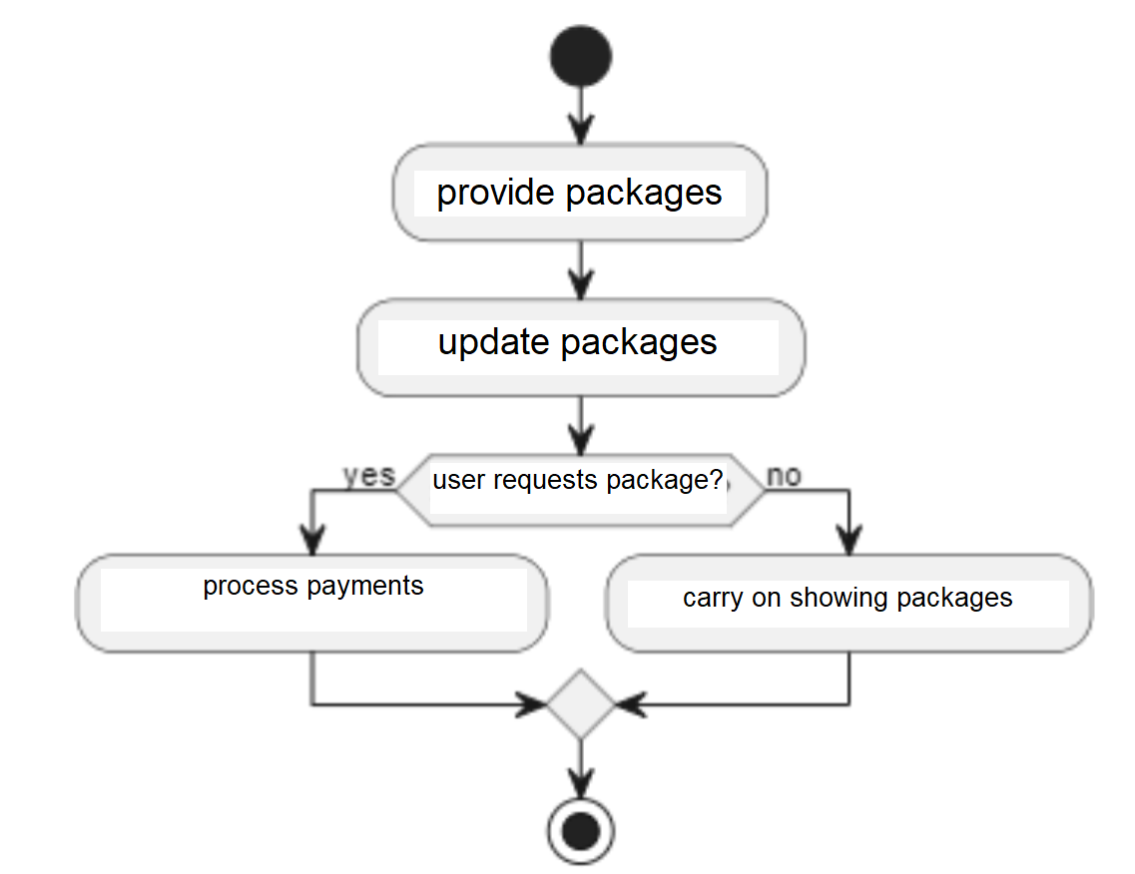

**Fig.3: vendor Activity diagram**

## DATA FLOW DIAGRAM

**Zero Level**

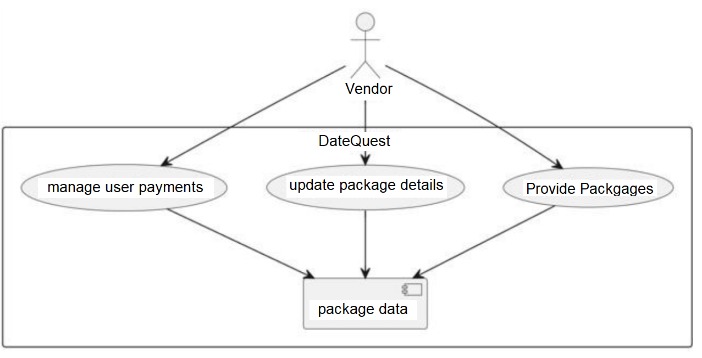

**Fig.4: Vendor Dataflow diagram**

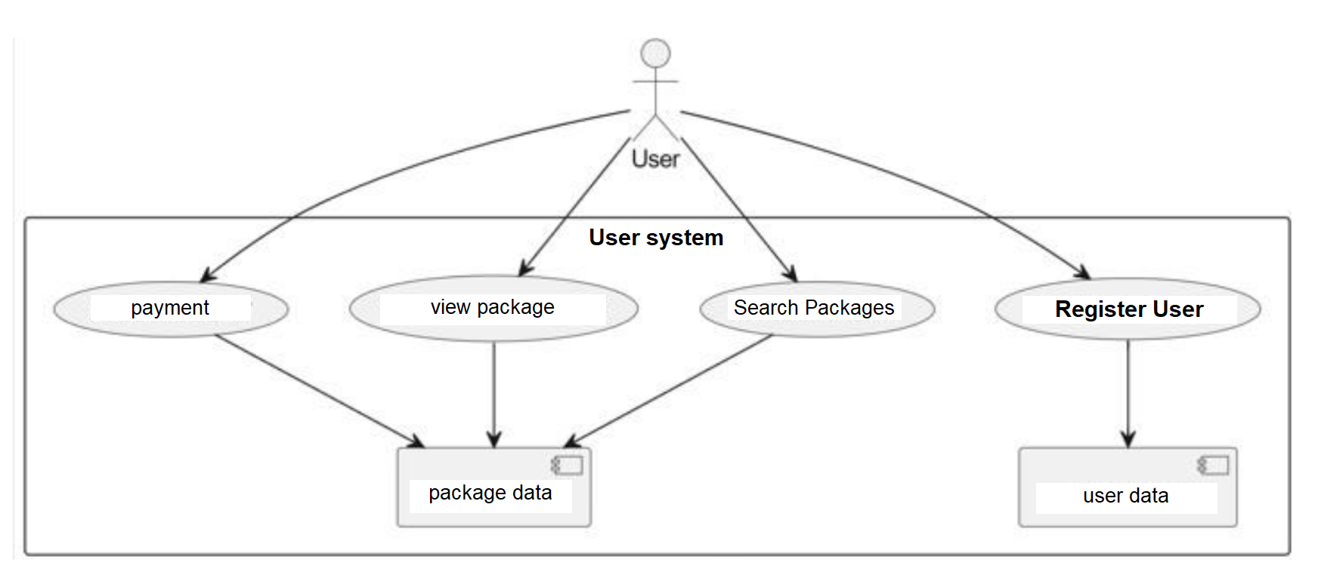

**Fig.5: User Dataflow diagram**

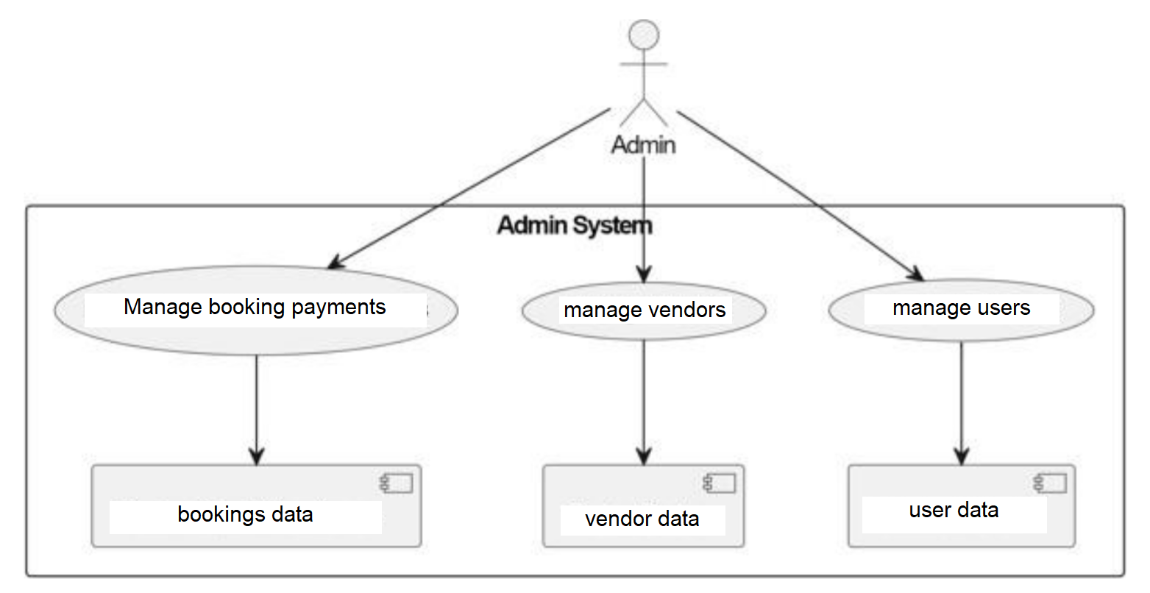

**Fig.6: Admin Dataflow diagram**

**1 Level Diagram**

**Vendor**

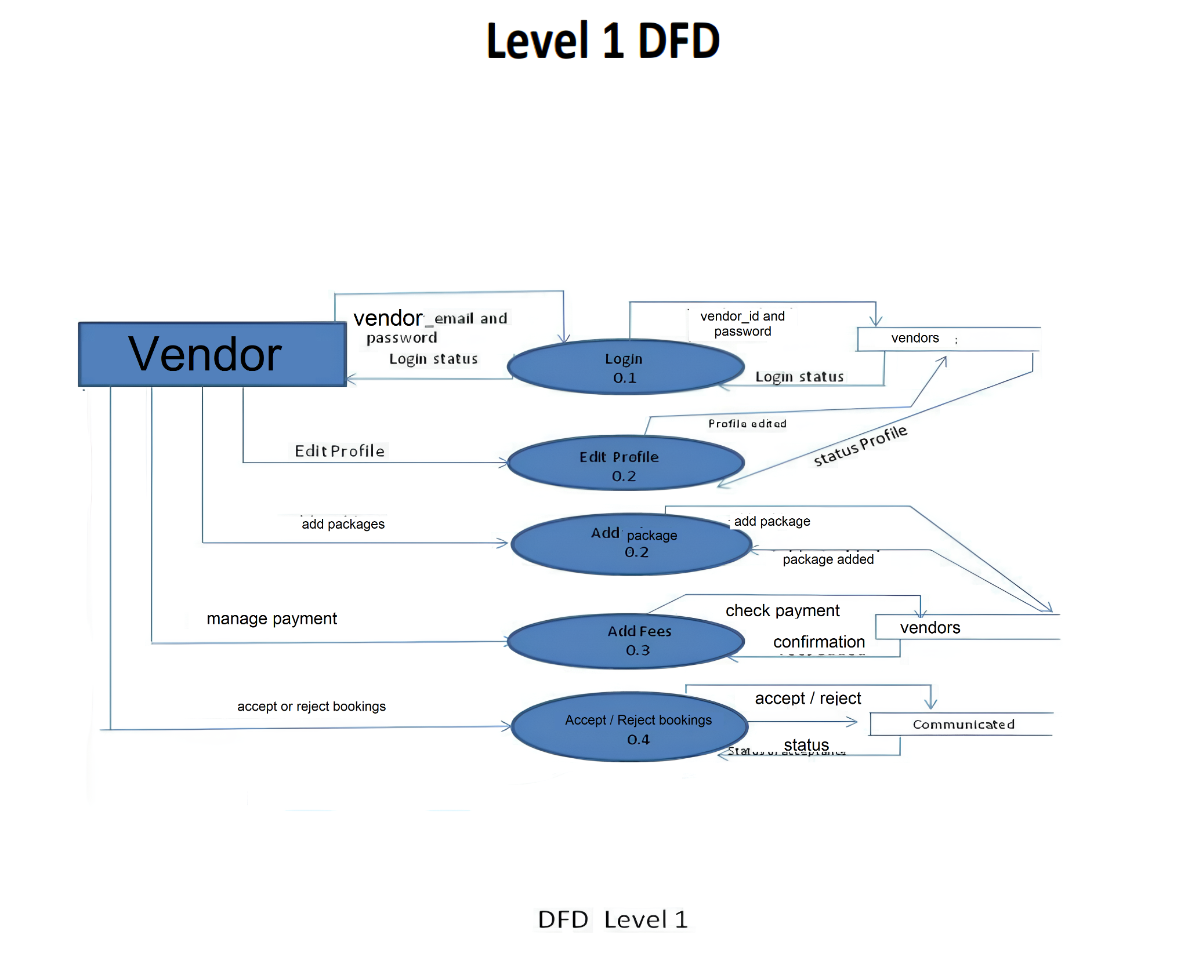

**User**

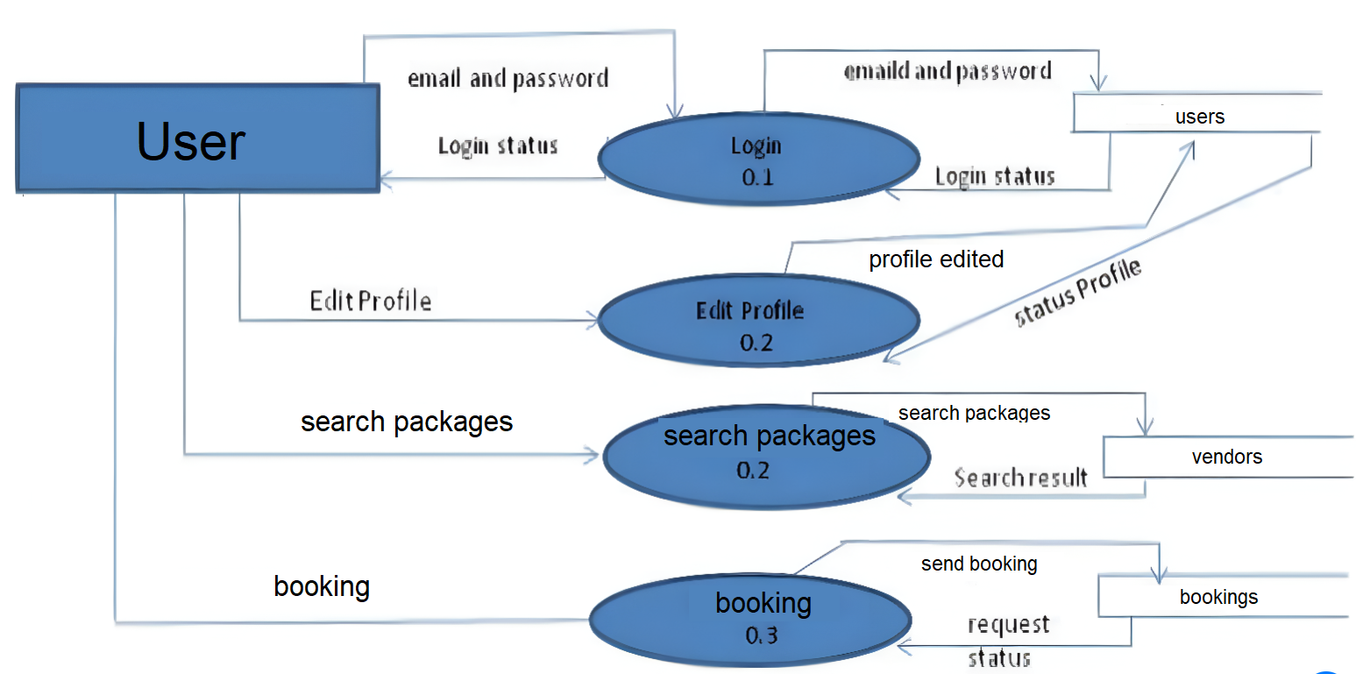

## Class DIAGRAM

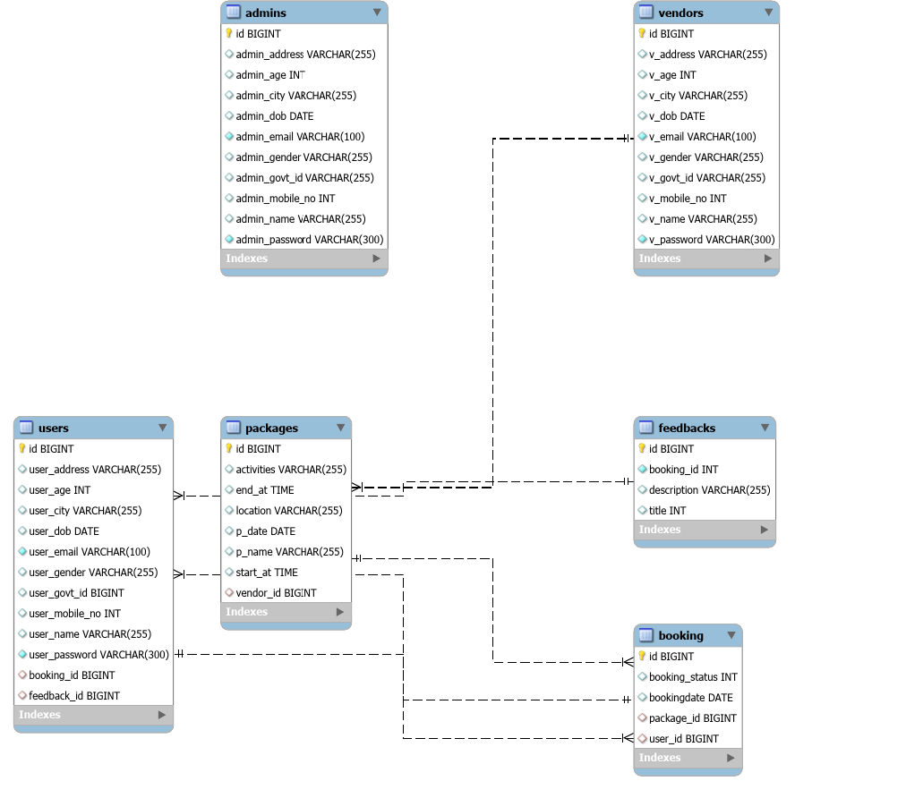

**Fig.7: Class diagram**

## USE CASE DIAGRAM

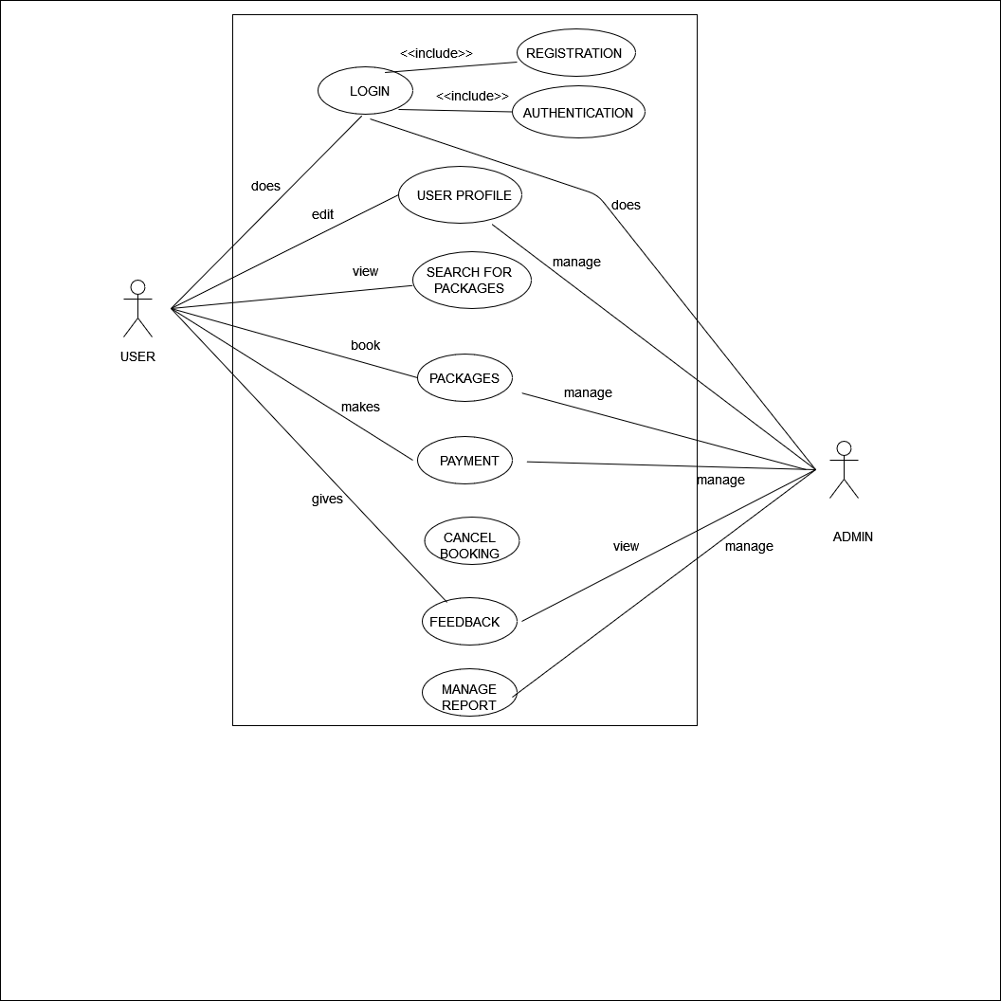

**Fig.8: Use Case diagram**

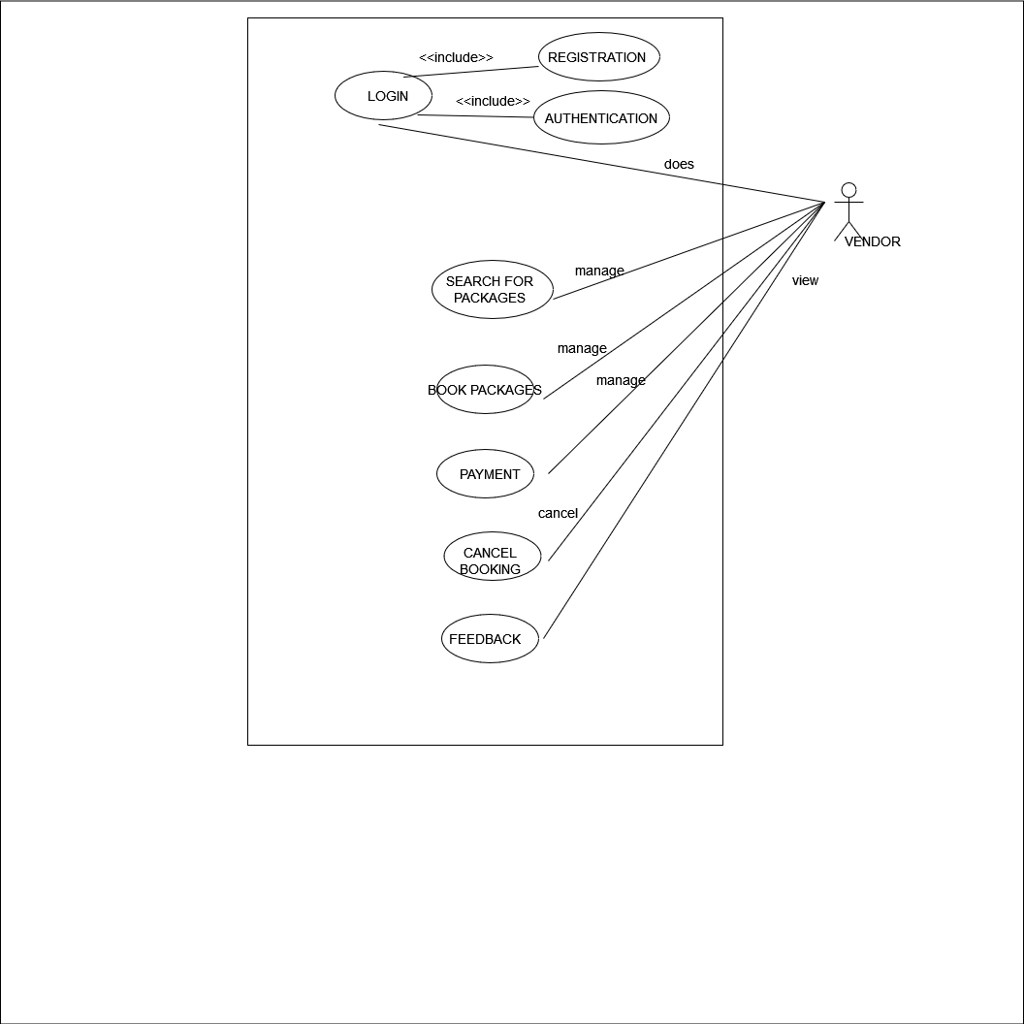

## ER DIAGRAM

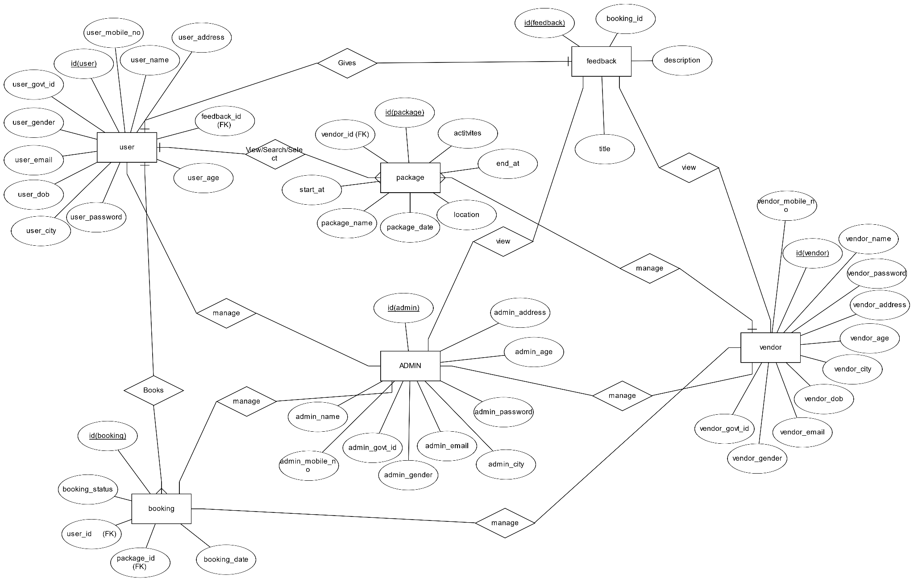

**Fig.9: ER diagram**

## SEQUENCE DIAGRAM

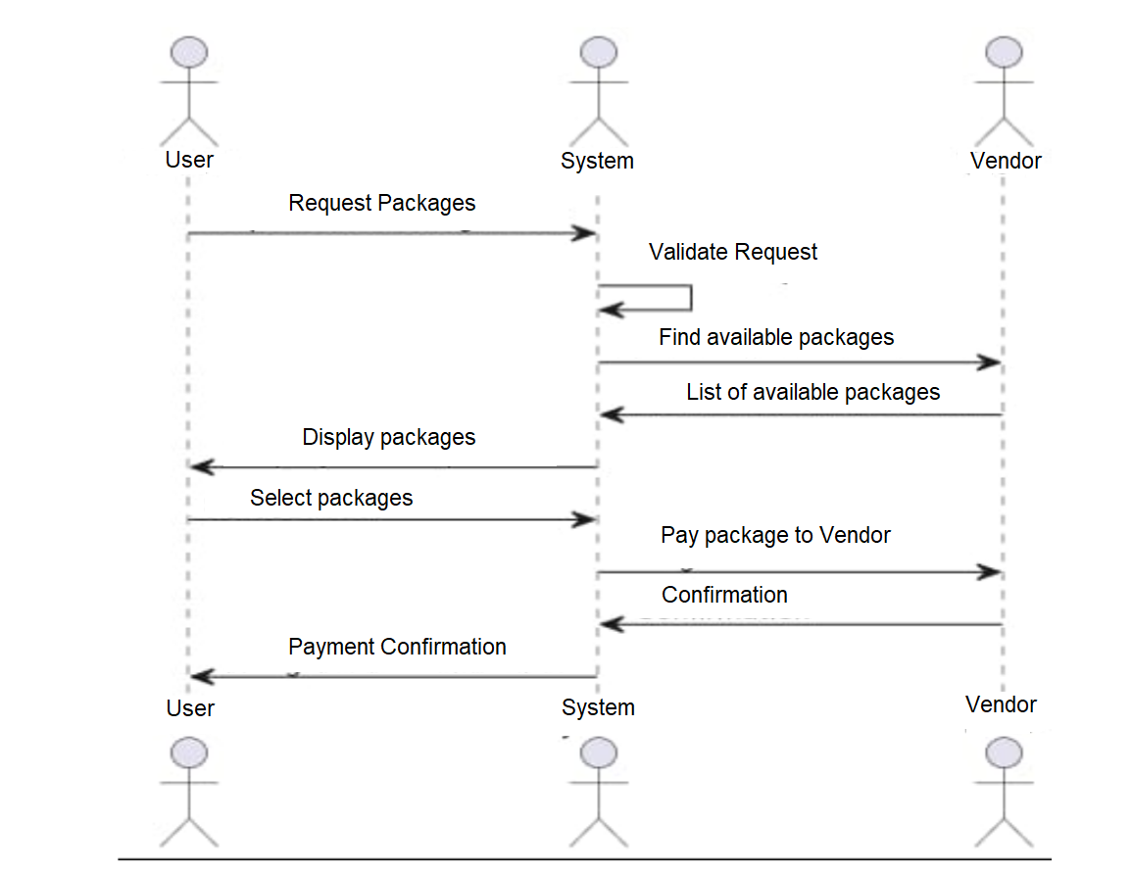

**Fig.10: Sequence diagram**

# TABLE STRUCTURE

## Tables:

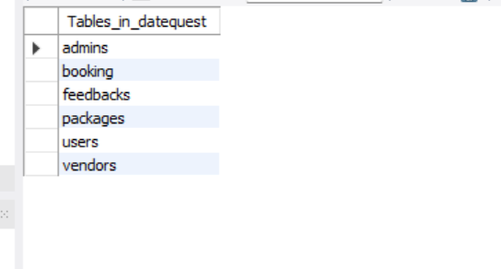

**User table**

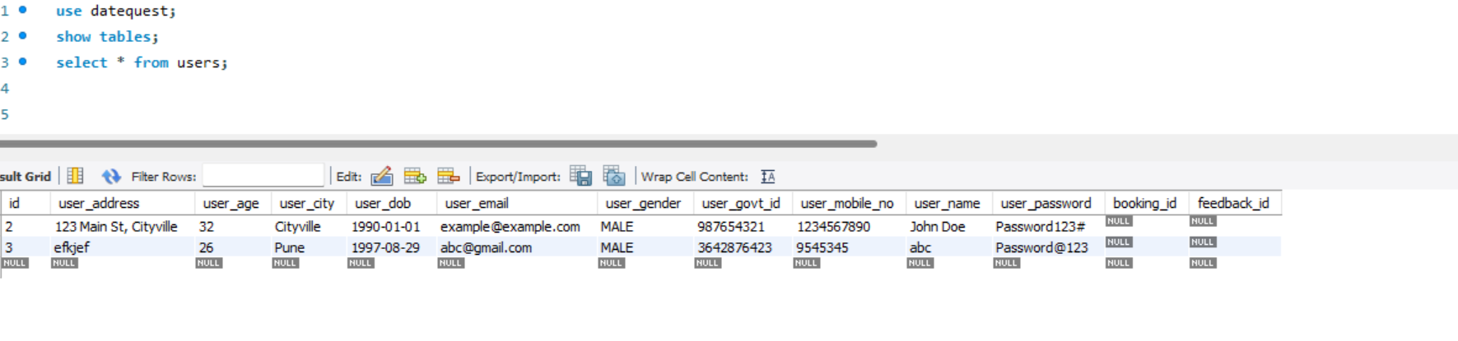

**Vendors Table**

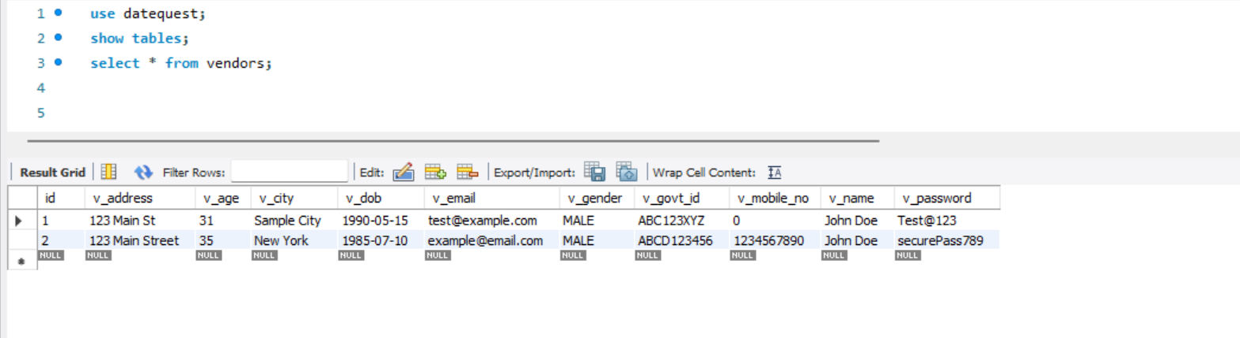

**Packages table**

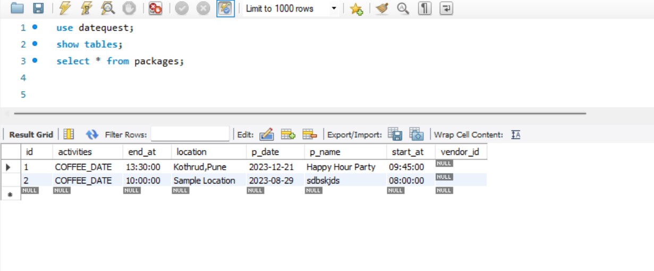

# PROJECT PHOTOS

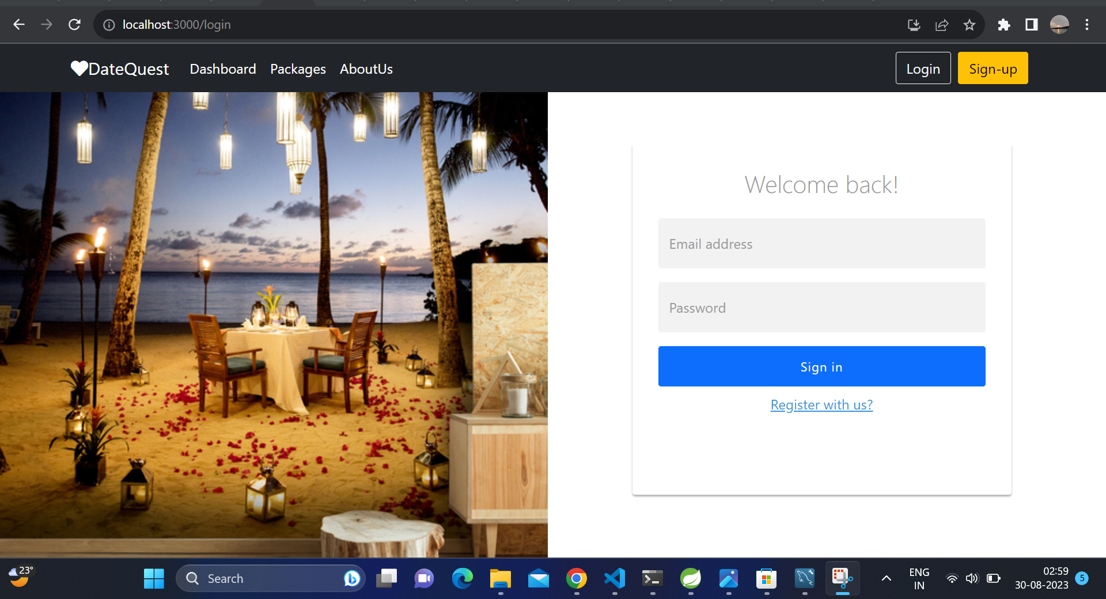

**6.1 Home Page**

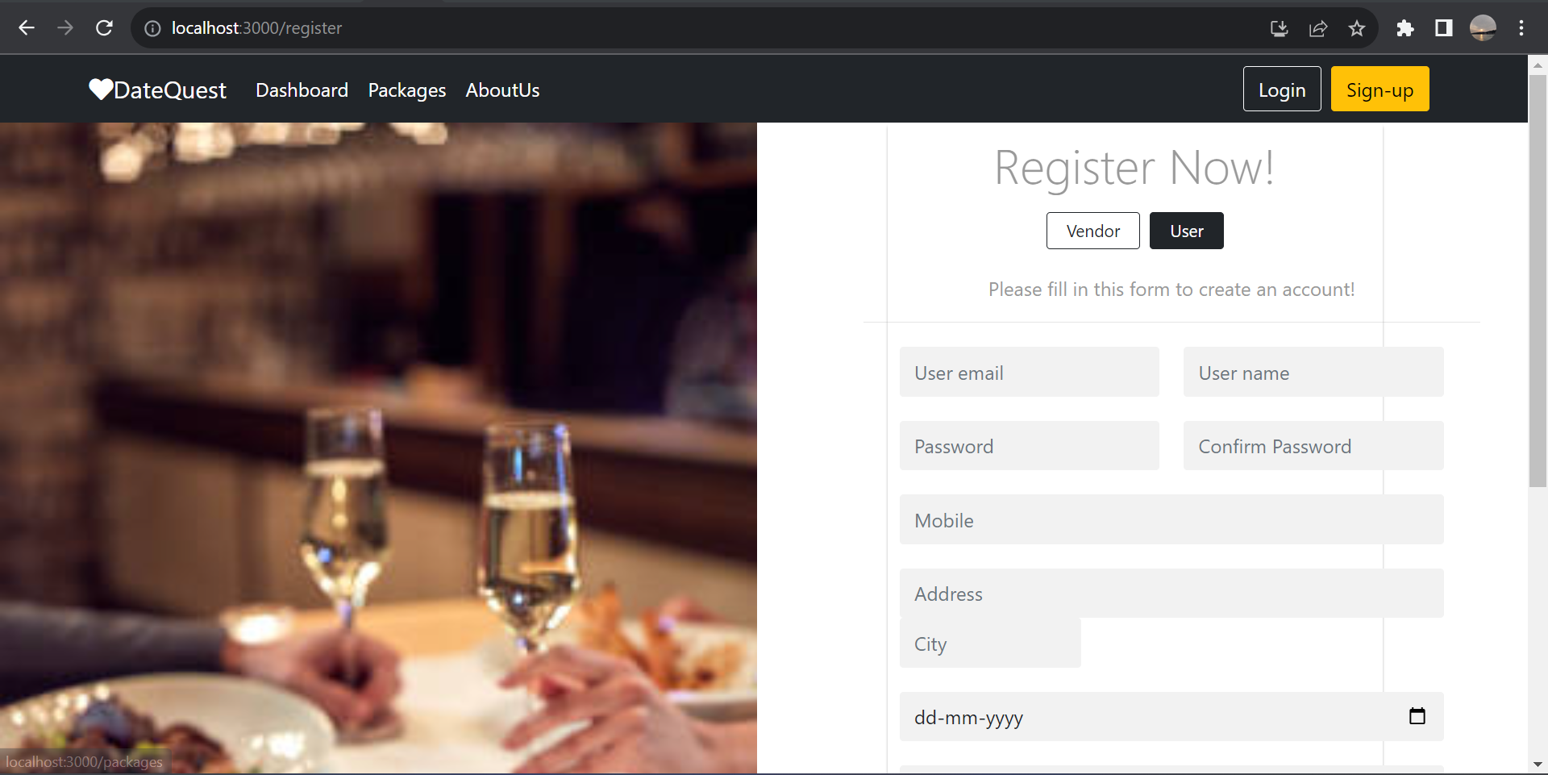

* 1. **User-Registration Page**

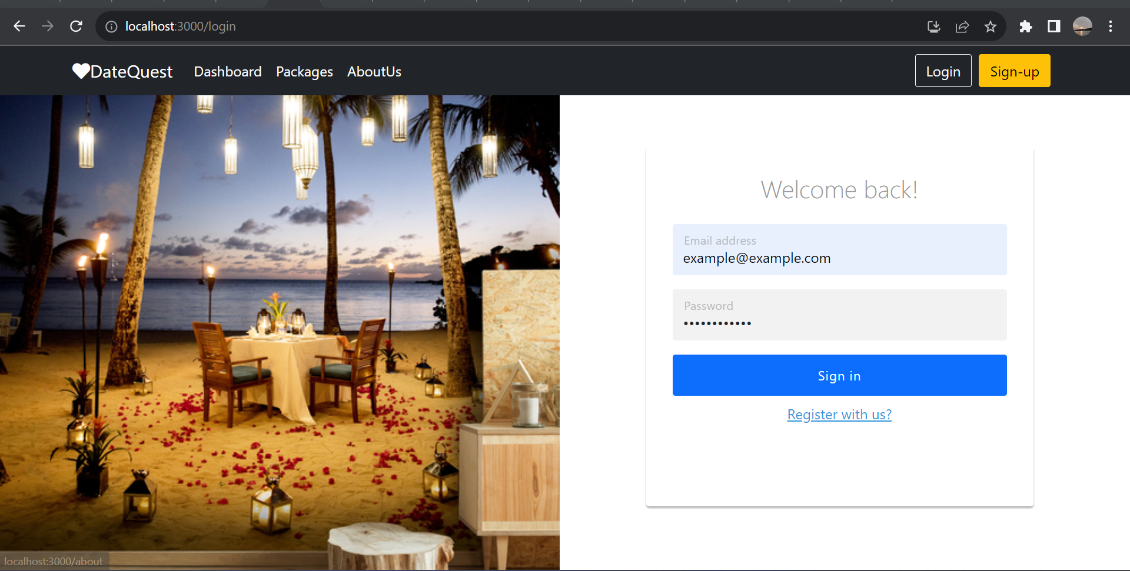

**6.3 Login Page**

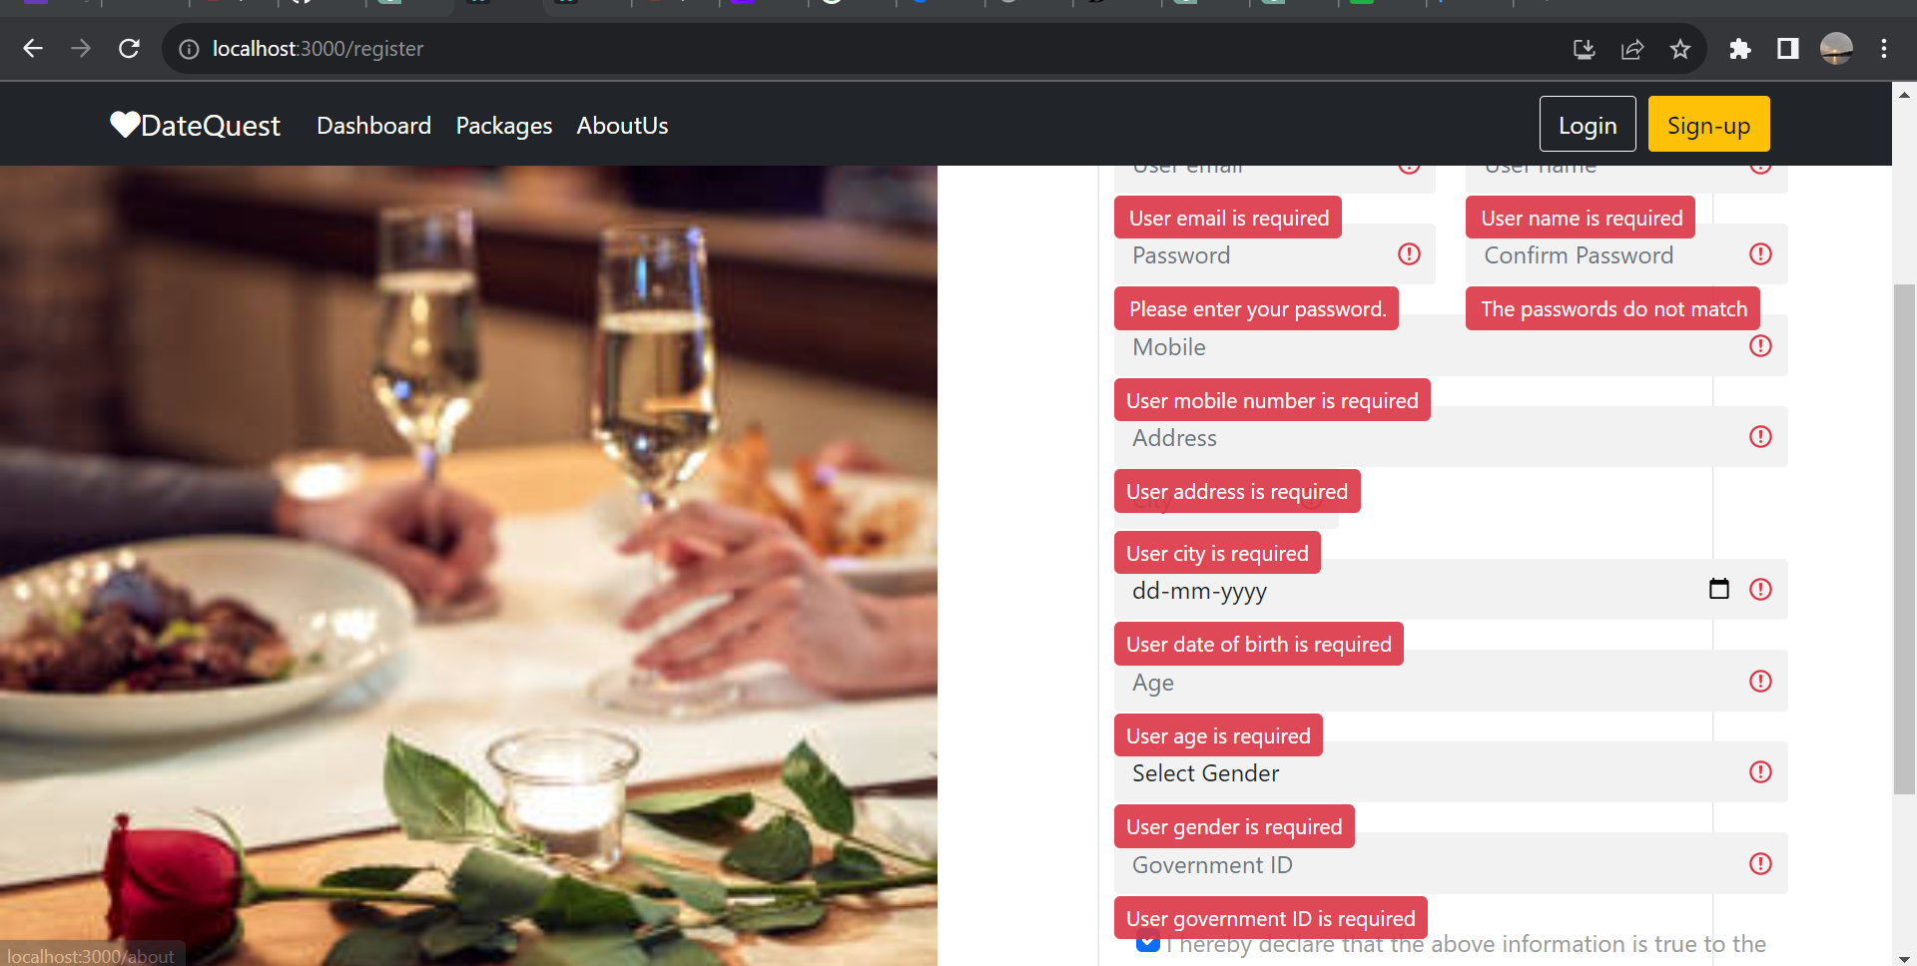

**6.4 Validation**

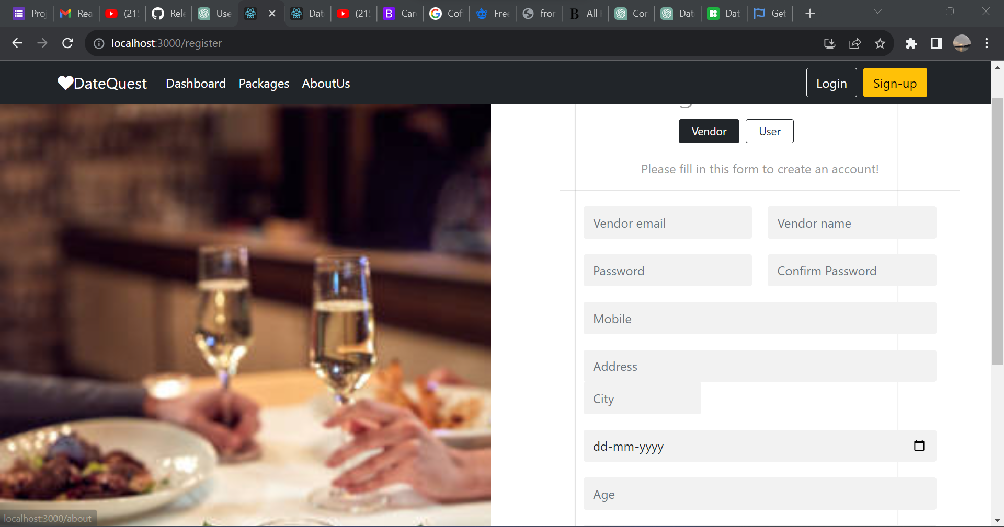

**6.5 Vendor-Registration Page**

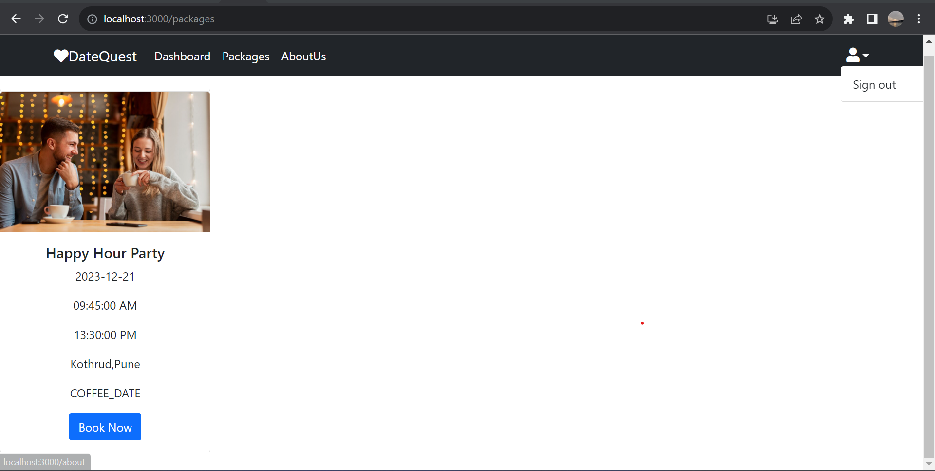

**6.6 Booking Packages**

**CONCLUSIO****N**

In conclusion, the "DateQuest" project has successfully developed an innovative web application that redefines the landscape of date planning and booking for couples. By harnessing technology, we've created a user-centric platform that simplifies the process, revolutionizing the way couples embark on memorable outings.

"DateQuest" is more than just an application; it's a catalyst for enhancing the quality of shared moments. By offering a diverse range of activities and vendors at couples' fingertips, we've made date planning a seamless and enjoyable experience. Our project strives to bridge the gap between couples and their leisure activities, ensuring that each outing is tailored to their preferences and interests.

Through innovation and a commitment to excellence, we present a solution that not only addresses the challenges of modern scheduling but also enriches the way couples create and cherish their memories together. The "DateQuest" application embodies the spirit of technological advancement, fostering connections and enhancing the overall quality of leisure experiences. As we celebrate this achievement, we look forward to seeing how "DateQuest" reshapes the future of date planning for couples worldwide.

# REFERENCES

1. Mc GrawHill’s , Java : The complete reference 7thEdition, Herbert Schildit
2. Complete CSS Guide, Maxine Sherrin and John Allsopp-O'ReillyMedia; September 2012

## ONLINE REFERENCE

* 1. [www.Google.com](http://www.google.com/)
  2. [www.w3school.com](http://www.w3school.com/)
  3. [www.javatpoint.com](http://www.javatpoint.com/)